DB2
Lab Book

Document Revision History

Date | Revision No. | Author | Summary of Changes
10-Nov-2009 | 4.0 | Arjun Singh | Content creation
16-Nov-2009 |  | CLS Team | Review
30-Jun-2011 | 5.0 | Rajita Dhumal | Revamped
8th-Aug-2012 | 5.1 | Rajita Dhumal | Revamped after Assignment Review

Table of Contents
Document Revision History 2
Table of Contents 3
Getting Started 4
Overview 4
Pre-requisite 4
Requirements 4
Lab 1. Execution of SQL queries using SPUFI 5
Lab 2. Data Query Language 8
Lab 3. Single Row Functions 10
Lab 4. JOINS AND SUBQUERIES 12
Lab 5. Set Operators 15
Lab 6. DB2 Objects 17
Lab 7. Data Manipulation Language 21
Lab 8. Using and execution of embedded SQL (on IBM Mainframes) 24
8.1: Create table definitions using DCLGENs 24
Lab 9. Using and execution of embedded SQL (on IBM Mainframes) 32
Write a COBOL programs: 32
Lab 10.Using and execution of embedded SQL (on IBM Mainframes) 34
Lab 11.Problem statements based on Analysis, Debugging and Enhancement tasks 37
Appendices 39
Appendix A: JCL’s 39
Appendix B: DB2 datatypes and the COBOL equivalent Picture 43
clauses 43
Appendix C: SQLCA 44
Appendix D :List of SQL codes 45
Lab 12. Using and execution of embedded SQL (CA-Realia Workbench ) 46

Getting Started

Overview
This lab book is a guided tour for learning DB2. It comprises assignments.

Pre-requisite
It is expected that participants know the following:

- Good knowledge of COBOL, JCL and SQL
- Using the ISPF editor
- Various options available on ISPF such as dataset allocation, copy, member list of PDS, how to compress PDS, etc.
- How to compile and view compilation errors, correct those errors
- How to submit jobs and view job log (=S.ST), SYSOUT

Requirements

You need three PDS, one each for storing DB2 source code, JCL code and loadlib. The convention followed for naming the PDS is as follows:

IBMID.NAME.X where IBMID is IBM login id used by the participant, NAME is name of the participant and X is either DB2SORCE or DB2JCL or DBMRLIB or LOADLIB.

E.g. the participant using IBM login id DA0002T and name as ANNETTE will have three PDS as follows:

DA0000T.ANNETTE.DB2SORCE – for storing DB2 source programs as PDS
members
DA0000T.ANNETTE.DB2JCL – for storing the DB2 JCL’s as PDS members
DA0000T.ANNETTE.DBRMLIB – for storing the DBRM modules
DA0000T.ANNETTE.LOADLIB – for storing load modules of programs as PDS
members
If these PDSs do not exist, then these are to be allocated as described below.

After logging on to IBM mainframe, on the ISPF main menu, type 3.2 against Option as shown in the figure below.

- Execution of SQL queries using SPUFI

Goals | - Understand how to execute queries using SPUFI.
 | 15 Min.

Objective:

Query the employee and dept tables created by DA0021T.

Input :

SELECT statement(s).

Program Specifications:

Display all the records from DA0021T.EMPLOYEE (Employee table) and DA0021T.DEPT (Department table).

Steps

- Allocate a sequential dataset named SQLIN. This dataset will be required to specify the queries.
- Go to DB2I from ISPF options.
- Select SPUFI from the DB2I PRIMARY OPTION MENU.
- 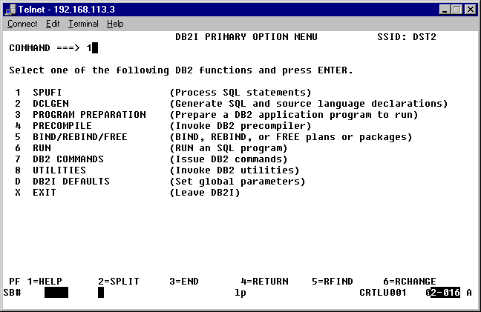
Figure 11
In the SPUFI screen you will specify the name of the sequential dataset we have allocated. The name of the output data set will have to be specified also. But this dataset need not be allocated.

Note : Edit input is YES. The moment you hit the Enter key the input dataset will be opened in the ISPF editor.

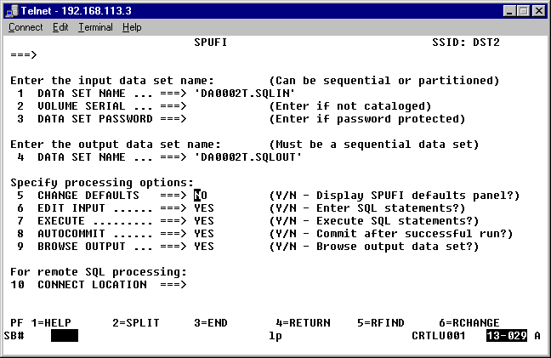

Key in the following query statements :
SELECT *
FROM DA0021T.EMPLOYEE;
SELECT *
FROM DA0021T.DEPT;

After keying in the queries, exit from the editor by entering END against Command or hitting the PF3 key. This will take you back to the SPUFI screen.

Note : An * appears against Edit input . Hit Enter. This will cause the queries in the input data set to be executed and the output will be directed to the output dataset.

Once the queries have been executed the output data set is automatically opened in the editor. You can scroll through the contents of this output dataset.
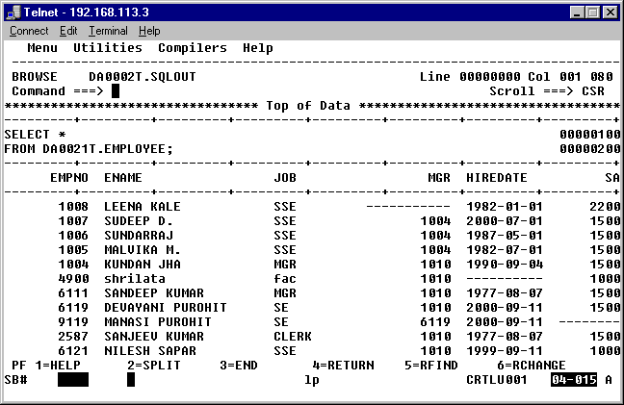

Key in END against Command or use the PF3 key to exit from this screen. Incase no more queries are to be keyed in exit from each screen till you come to the ISPF main menu.

- Data Query Language

Goals | - Understand how to use various clauses of SELECT statement
Time | 45 min
1. List Name, Sal, Comm, and deptno of the employees who are working in department 20, 30 and 40. (To Do)

2. List the details of the employees with elaborated Column headers.

Select Empno as "Employee Number",
Ename as "Employee Name",
Job as "Designation",
Mgr as "Manager Number",
Hiredate as "Date of Joining,
Sal as "Salary”,
Comm as "Commission",
DeptNo as "Department Number"
from emp;

Example 1: Sample Code

3. List the Department name, Location Name, number of employees, and the average salary for all employees in that department, and label the columns Count(*) as Number of People.

Select D.dname,D.Loc,
count(*) "Number of People",
avg (sal) "Salary"
from Emp E, Dept D wheree.deptno=d.deptno
group by dname,loc

Example 2: Sample Code

4. List the details of the employees whose designations are either CLERK or SALESMAN. (To Do)

5. List the empno, name, and Department No of the employees who have experience of more than 18 years. (To Do)
6. List the name and Designations of the employees who have joined before Jan 1982.

7. List the name, designation, and income for 10 years annual income of the employees who are working in departments 10 and 30. (To Do)

8. List the name and experience (in years) of employees who are working as CLERKS. (To Do)

9. List the details of the Department where the Location of the department is in 'BOSTON'. (To Do)

10. List the Name and Salary of the employees who are earning between 1000 and 3000. Sort them based on their salaries and name. (To Do)

11. Display employees who do not have manager. (To Do)

12. Display details of all employees whose job is Clerk or Analyst, and whose salary is not equal to $2500, $3500, or $7000. (To Do)

13. Get the Department number, and sum of Salary of all non managers and president in that department, where the sum is greater than 2000. Order the output with the highest total at the top.

14. Get the employee name, salary, and annual salary for only those employees whose annual salary is greater than 20000. Order the result in increasing order of annual salary.

- Single Row Functions

Goals | - Learning various Single Row Functions
Time | 45 min
    - Find the total experience of all employees present in EMP table. (To Do)

    - List the details of the employees, whose names start with ‘A’ and end with ‘S’. (To Do)

    - List the name and job of the employees whose names should contain N as the second or third character, and ending with either ‘N’ or ‘S’. (To Do)

    - List the name of the Employees, who have joined in the year 1982. (To Do)

    - List the names of the Employees having % character in their name. (To Do)

    - List the details of the employees who have joined in December (irrespective of the year). (To Do)

    - List the name, experience in Years, and commission of employees whose job is PRESIDENT. If Commission exists, then display it, otherwise display ‘0’ in Commission column. (To Do)

    - Show employee’s names with the respective numbers of asterisk from Emp table. (To Do)

    - Show employee’s names with the respective numbers of asterisk from Emp table except first and last characters. For example: KING will be replaced with K**G.
(To Do)

    - Show all employees who were hired in the first half of the month. (To Do)
    - Display the ename, hiredate and day of the week on which the employee joined. Order the results by the day of the week starting with Monday. (To Do)
- JOINS AND SUBQUERIES

Goals | - Solving the complex queries using Joins and Subqueries
Time | 90 Min
1. List name, job, and deptno of the employees who are having the same job as that of any employee of department no 20. Sort them in an ascending order by deptno. (To Do)

2. List lowest paid employees working for each manager. Sort the output by salary. (To Do)

3. List the three least paid employees in EMP table. Sort the result by salary in an ascending order.

4. Using a sub query, list the employee name and job of employees who are not from CHICAGO location. (To Do)

5. List the employee name and department name of all employees working in a department, which has at least three employees working in it. (To Do)
6. List all grades and the number of employees in each grade. (To Do)

9. Observe the following tables, and pick up the employee, who is a 3GLS capable and stays in CHICAGO. Write the SQL query to retrieve the Employee details.
(To Do)

EMP
EMPN0 INTEGER
HOTELNAME VARCHAR(10)

COURSEDONE
EMPNO INTEGER
COURSENO INTEGER

COURSEMASTER
COURSENO, INTEGER
COURSENANE VARCHAR(10)

HOTEL
HOTELNAME VARCHAR(10)
ADDRESS VARCHAR(10)
DETAILS IN EMP TABLE
EMPNO HOTELNAME
101 RAMADA
102 WELCOME
103 TAJ
104 OBEROX
105 WELCOME

DETAILS IN COURSEDONE TABLE
EMPNO COURSENO
101 2
102 1
103 3
101 4
102 5
104 1

DETAILS IN COURSEMASTER TABLE
COURSENO COURSENAME
1 3GLS
2 COBOL
3 4GLS
4 PASCAL
5 ORACLE

DETAILS IN HOTEL TABLE
HOTELNAME ADDRESS
RAMADA NEWYORK
WELCOME ILLINOIS
TAJ NEWJZRSEY
OBEROX CHICAGO

10. Write the query to display the details of employees, who belong to such a department whose (departments) sum of salary is maximum. (To Do)

11. Show all employees who were hired on the day of the week on which highest number of employees were hired. (To Do)

12. Write a query to display the details of such a department, where no sales representatives work. (To Do)
13. List all employees with their names, salary, and incremented salary at 10% of the average salary. (To Do)

14. Get the names of all employees, who are earning the maximum salary in their respective departments. (To Do)

15. Write a query to get the details of oldest and the newest employees in the organization, in terms of experience in the company. (To Do)

- Set Operators

Goals | - Learning Set Operators
Time | 15 min

Observe the following queries and do the given assignments.

create table previous_products (
pid int,
name varchar(40),
unit varchar(40),
price int,
stock int );

Example 3: Sample Code

create table current_products (
pid int,
name varchar(40),
unit varchar(40),
price int,
stock int );

Example 4: Sample Code

insert into previous_products values(7,'Uncle Bob''s Organic Dried Pears','12 - 1 lb pkgs.',30.00,15);
insert into previous_products values(8,'Northwoods Cranberry Sauce','12 - 12 oz jars',40.00,6);
insert into previous_products values(1,'Chang','24 - 12 oz bottles',19.00,17);
insert into previous_products values(3,'Aniseed Syrup','12 - 550 ml bottles',10.00,13);
insert into previous_products values(4,'Chef Anton''s Cajun Seasoning','48 - 6 oz jars',22.00,53);
insert into previous_products values(5,'Chef Anton''s Gumbo Mix','36 boxes',21.35,0);
insert into previous_products values(6,'Grandma''s Boysenberry Spread','12 - 8 oz jars',25.00,120);

Example 5: Sample Code

insert into current_products values(7,'Uncle Bob''s Organic Dried Pears','12 - 1 lb pkgs.',30.00,15);
insert into current_products values(8,'Northwoods Cranberry Sauce','12 - 12 oz jars',40.00,6);
insert into current_products values(9,'Mishi Kobe Niku','18 - 500 g pkgs.',97.00,29);
insert into current_products values(10,'Ikura','12 - 200 ml jars',31.00,31);
insert into current_products values(11,'Queso Cabrales','1 kg pkg.',21.00,22);
insert into current_products values(5,'Chef Anton''s Gumbo Mix','36 boxes',21.35,0);
insert into current_products values(6,'Grandma''s Boysenberry Spread','12 - 8 oz jars',25.00,120);

Example 6: Sample Code
1. Get the details of all products irrespective of the fact whether they are in previous set or current set. (To Do)

2. Get the details of all products along with the repetition of those that were present both in the previous and current sets. (To Do)

- DB2 Objects
Goals | - Learning various commands to define Database Objects
Time | 90 min

1. Create the Customer table with the following columns. (To Do)
Customerid INTEGER(5)
CustomerName INTEGER(10)
Address1 VARCHAR(30)
Address2 VARCHAR(30)

2. Modify the Customer table CustomerName column of datatype with VARCHAR(30). CustomerName should not accept Nulls. (To Do)

3. Add the following Columns to the Customer table. (To Do)
Sex VARCHAR(1)
Age INTEGER(3)
PhoneNo INTEGER(10)
Income INTEGER(10,2)
4. Insert rows with the following data in to the Customer table.
Insert into customer values: (1000, ‘Allen’, ‘#115 Chicago’, ‘#115 Chicago’, ‘M’, ‘25, 7878776’, 10000)
In similar manner, add the below records to the Customer table (To Do):
- 1000, Allen, #115 Chicago, #115 Chicago, M, 25, 7878776, 10000
- 1001, George, #116 France, #116 France, M, 25, 434524, 20000
- 1002, Becker, #114 New York, #114 New York, M, 45, 431525, 15000.50

5. Add the Primary key constraint for Customerld with the name Custld_Prim.

6. Insert the row given below in the Customer table and see the message generated by the database server. (To Do)
- 1002, John, #114 Chicago, #114 Chicago, M, 45, 439525, 19000.60

9. Drop the constraint Custld_Prim on CustomerId and insert the following Data. Alter Customer table, drop constraint Custid_Prim.
- 1002, Becker, #114 New York, #114 New york , M, 45, 431525, 15000.50
- 1003, Nanapatekar, #115 India, #115 India , M, 45, 431525, 20000.50

12. Drop the GrossIncome column from Customer table. (To Do)
13. Add a new column AnnualIncome to Customer table. (To Do)

14. Create the Suppliers table based on the structure of the Customer table. Include only the CustomerId, CustomerName, Address1, Address2, and phoneno columns.
Name the columns in the new table as SuppID, SName, Addr1, Addr2, and Contactno respectively. (To Do)

15. Drop the Customer table referred above and recreate the following table with the name Customer. (To Do)
CustomerId INTEGER(5) Primary key(Name of constraint is CustId_Prim)
CustomerName VARCHAR(30) Not Null
Addressl VARCHAR(30) Not Null
Address2 VARCHAR(30)
Sex VARCHAR(l)
Age INTEGER(3)
PhoneNo INTEGER(10)
Income INTEGER(10,2)

16. Create the Transactions table with the following Columns. (To Do)
Customerld INTEGER(5)
CustomerName VARCHAR(10)
Debit INTEGER(10,2)
Credit INTEGER(10,2)
Balance INTEGER(10,2) Not Null
TransactionDate Date

17. Relate Transactions table and Customer table through Customerld column with the constraint name Cust_tran.

Alter table Transaction
Add constraint Cust_Tran foreign key (Customerld)
References Customer (Customerld);

Example 7: Sample Code

18. Insert the following rows in Customer table (To Do):
- 1000, Allen, #115 Chicago, #115 Chicago, M, 25, 7878776, 10000
- 1001, George, #116 France, #116 France, M, 25, 434524, 20000
- 1002, Becker, #114 New York, #114 New York, M, 45, 431525, 15000.50

19. Insert the following rows to the Transactions table (To Do):
- 1000,Allen, 3000,2000,1000, 10 Oct 92
- 1001,George, 6000,2000,4000,08 Sep 92
- 1002, Becker, 10000,2000,8000,4 Nov 92
- 1003, 'Bill', 30000,2000, 280000,4 Nov 92

20. Modify the Transaction table with the Check constraint to ensure Credit should not be greater than Debit + Balance. (To Do)

21. Modify the Transaction table keeping a Check constraint with the name Balan_Check for the Minimum Balance which should be greater than 500. (To Do)

22. Modify the Transaction table such that if Customer is deleted from Customer table then all his transactions should be deleted from Transaction table. (To Do)

23. Create Backup copy for the Transactions table with the name ‘TransactionsPerDay’. (To Do)
24. Create a view ‘Trans_view’ with columns Customerld, CustomerName, Debit, Credit, and Balance from Table Transaction. In the view Transview, the columns names should be accountId, AccountHolderName, Debit, Credit, and Balance for the respective columns from Transaction table. (To Do)

25. Insert the following rows into Trans_View (To Do):
- 5000,George,0,2000,2000,

26. Create a join view on EMP table and DEPT table with the name vw_EMP_DEPT containing columns such as ename, dname, deptno, sal, etc. (To Do)

27. Create a Unique index with the name No_Name on DeptNo and Dname of Dept table. (To Do)

- Data Manipulation Language

Goals | - Use various DML commands to manipulate the underlying database objects
Time | 30 min

1. Create Employee table with same structure as EMP table.

SQL>Create table employee as select * from emp where 1=3
SQL>desc employee

Name | Null? | Type
EMPNO | NOT NULL | INTEGER(4)
ENAME |  | VARCHAR(10)
JOB |  | VARCHAR(50)
MGR |  | INTEGER(4)
HIREDATE |  | DATE
SAL |  | INTEGER(7,2)
COMM |  | INTEGER(7,2)
DEPTNO |  | INTEGER(2)

SQL>select * from employee
no rows selected
2. Write a query to populate Employee table using EMP table’s empno, ename, sal, deptno columns. (To Do)

SQL>select * from employee
EMPNO | ENAME | JOB | MGR | HIREDATE | SAL | COMM | DEPTNO
7369 | SMITH |  |  |  | 800 |  | 20
7499 | ALLEN |  |  |  | 1600 |  | 30
7521 | WARD |  |  |  | 1250 |  | 30
7566 | JONES |  |  |  | 2975 |  | 20
7654 | MARTIN |  |  |  | 1250 |  | 30
7698 | BLAKE |  |  |  | 2850 |  | 30
7782 | CLARK |  |  |  | 2450 |  | 10
7788 | SCOTT |  |  |  | 3000 |  | 20
7839 | KING |  |  |  | 5000 |  | 10
7844 | TURNER |  |  |  | 1500 |  | 30
7876 | ADAMS |  |  |  | 1100 |  | 20
7900 | JAMES |  |  |  | 950 |  | 30
7902 | FORD |  |  |  | 3000 |  | 20
7934 | MILLER |  |  |  | 1300 |  | 10
14 rows selected.

3. Write a query to change the job and deptno of employee whose empno is 7698 to the job and deptno of employee having empno 7788. (To Do)

4. Delete the details of department whose department name is ‘SALES’. (To Do)

5. Write a query to change the deptno of employee with empno 7788 to that of employee having empno 7698. (To Do)

6. Insert the following rows to the Employee table
- 1000,Allen, Clerk,1001,12-jan-01, 3000, 2,10
- 1001,George, analyst, null, 08 Sep 92, 5000,0, 10
- 1002, Becker, Manager, 1000, 4 Nov 92, 2800,4, 20
- 1003, 'Bill', Clerk, 1002, 4 Nov 92,3000, 0, 20

- Using and execution of embedded SQL (on IBM Mainframes)

Goals | - Understand how to execute embedded SQL on IBM mainframes.
Time | 90 minutes
- Create table definitions using DCLGENs
- Key in the program
- Modify & submit the Precompile JCL
- Modify & submit the Bindplan JCL
- Modify & submit the Complink JCL and Run JCL
- Check the output

8.1: Create table definitions using DCLGENs

Select 2 from the DB2I Primary Option menu.
Enter the following details on DCLGEN screen
SOURCE TABLE NAME (name of the DB2 table qualified by the owner name).
DATA SET NAME (name of the member of a PDS. It should be the same PDS where you have your source code)

After the member is generated a confirmation message is displayed. To view the contents of DEPTDCL, return to the ISPF/PDF Primary Option Menu.

The contents of DEPTDCL contain the options select in DCLGEN, the table definition…
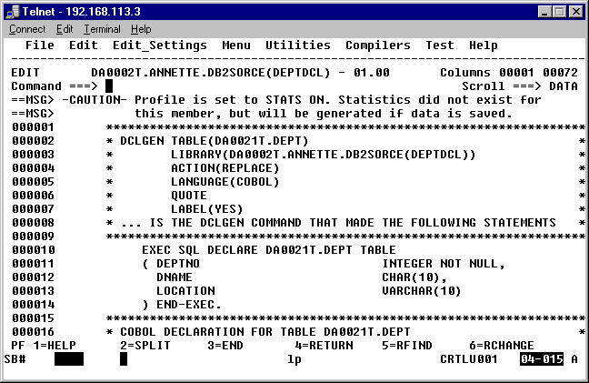
… and the COBOL variable definitions.
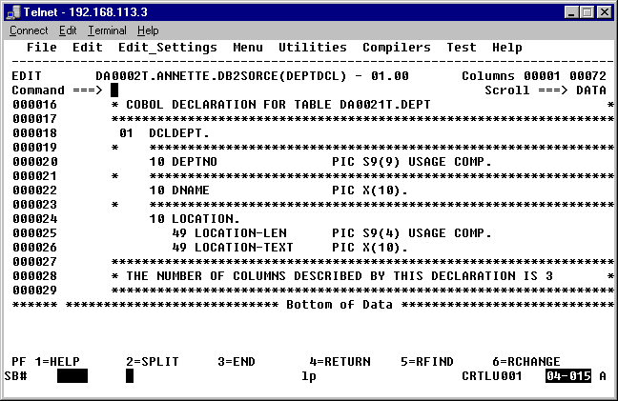

Key in the program
Key in the program using the ISPF editor.
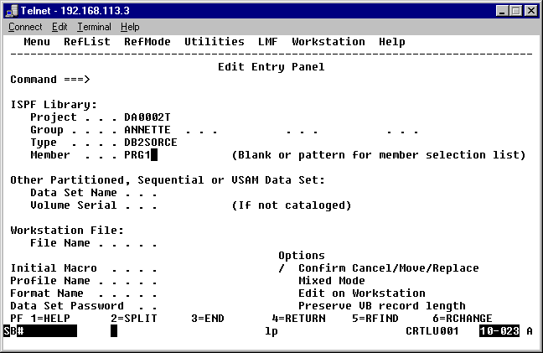
Figure 25

000100 IDENTIFICATION DIVISION.
000200 PROGRAM-ID. PRG1.
000300 AUTHOR. ANNETTE.
000302***************************************************************
000310* Display the name of the department, given the department no.*
000320***************************************************************
000400 ENVIRONMENT DIVISION.
000500 DATA DIVISION.
000600 WORKING-STORAGE SECTION.
000700 EXEC SQL
000710 INCLUDE DEPTDCL
000800 END-EXEC.
000900*
000910 EXEC SQL
000920 INCLUDE SQLCA
001000 END-EXEC.
001100 PROCEDURE DIVISION.
001200 0000-MAIN-PARA.
001210* Checking a row with salary as null.
001300 MOVE 10 TO DEPTNO.
001301 EXEC SQL
001820 SELECT DNAME
001830 INTO :DNAME
001840 FROM DA0021T.DEPARTMENT
001850 WHERE DEPTNO = :DEPTNO
001860 END-EXEC.
001861 DISPLAY 'DEPTNO : ' DEPTNO.
001700 STOP RUN.

- Modify & submit the Precompile JCL

//DA0002TP JOB (LA2719),'ANNETTE',CLASS=A,
// MSGCLASS=X,
// NOTIFY=DA0002T,
// TIME=(,01),
// REGION=4096K
//*ROUTE PRINT RMT196
//**************************************************************
//* THIS JCL PRECOMPLILES THE APPLICATION PGM
//* GENERATES PURE COBOL CODE AND A DBRM.
//**************************************************************
//PRECOMP EXEC PGM=DSNHPC,
// PARM='HOST(COBOL),APOST',REGION=4096K
//*
//* IN SYSIN GIVEN BELOW SPECIFY PGM NAME TO BE PRECOMPILED
//* B
//SYSIN DD DSN=DA0002T.ANNETTE.DB2SORCE(ASS1),DISP=SHR
//*
//SYSLIB DD DSN=DA0002T.ANNETTE.DB2SORCE,DISP=SHR
//*
//SYSUT1 DD UNIT=SYSDA,SPACE=(CYL,(5,5))
//SYSUT2 DD UNIT=SYSDA,SPACE=(CYL,(5,5))
//SYSUT3 DD UNIT=SYSDA,SPACE=(CYL,(5,5))
//STEPLIB DD DSN=SYS0.DB2.TEST.DSNLOAD,DISP=SHR
//*
//* HERE YOU SPECIFY O/P MEMBER OF PRECOMPILATION
//*
//SYSCIN DD DSN=DA0002T.ANNETTE.DB2SORCE(MASS1),
// DISP=(SHR),UNIT=SYSDA,
// SPACE=(CYL,(5,5,4))
//* HERE YOU SPECIFY MEMBER FOR DBRM
//DBRMLIB DD DSN=DA0002T.ANNETTE.DBRMLIB(DASS1),DISP=SHR
//* DISP=(NEW,KEEP),UNIT=SYSDA,
//* SPACE=(CYL,(5,5))
//*
//SYSPRINT DD SYSOUT=*
//SYSTERM DD SYSOUT=*
//SYSUDUMP DD SYSOUT=*
//

- Modify & submit the Bindplan JCL

//DA0002TB JOB (LA2719),'ANNETTE',CLASS=A,
// MSGCLASS=X,
// NOTIFY=DA0002T,
// TIME=(,01),
// REGION=4096K
//*ROUTE PRINT RMT196
//**************************************************************
//* THIS JCL BIND THE DBRM & GENERATES APPLICATION PLAN
//*
//**************************************************************
//BIND EXEC PGM=IKJEFT01,DYNAMNBR=20,REGION=512K
//STEPLIB DD DSN=SYS0.DB2.TEST.DSNLOAD,DISP=SHR
//*TEPLIB DD DSN=SYS1.DB2.SDSNLOAD,DISP=SHR
//*YSPROC DD DSN=SYS1.DB2.SDSNCLST,DISP=SHR
//*
//* HERE YOU SPECIFY DBRM LIBRARY
//*
//DBRMLIB DD DSN=DA0002T.ANNETTE.DBRMLIB,DISP=SHR
//*
//DB2ERROR DD SYSOUT=*
//CSABEND DD SYSOUT=*
//SYSABOUT DD SYSOUT=*
//SYSDBOUT DD SYSOUT=*
//SYSUDUMP DD SYSOUT=*
//SYSPRINT DD SYSOUT=*
//SYSTSPRT DD SYSOUT=*
//SYSOUT DD SYSOUT=*
//SYSTSIN DD *
DSN SYSTEM(DST2) RETRY(5) TEST(0)
BIND PLAN(DAPLAN1) -
MEMBER(DASS1) -
ACTION(REPLACE) RETAIN -
ISOLATION(CS) -
VALIDATE(RUN) -
ACQUIRE(USE) -
RELEASE(COMMIT)
END
/*

- Modify & submit the Complink JCL

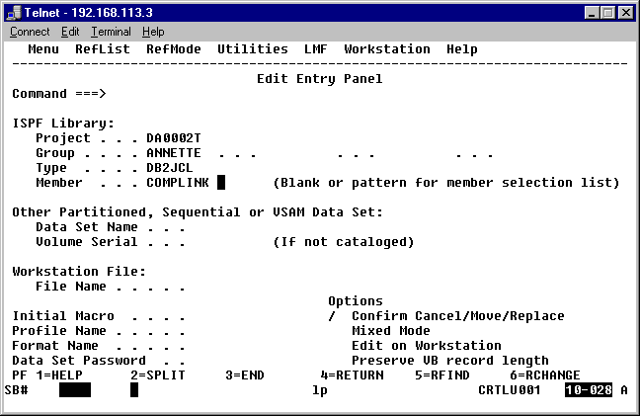
Figure 35

//DA0002TC JOB (LA2719),'ANNETTE',CLASS=A,
// MSGCLASS=X,
// NOTIFY=DA0002T,
// TIME=(,01),
// REGION=4096K
//***********************************************************
//* THIS JCL COMPILES AND LINK THE PRECOMPIED PGM
//*
//***********************************************************
//* THIS STEP COMPILES THE PRECOMPILED PGM
//***********************************************************
//COB EXEC PGM=IKFCBL00,REGION=1024K,
// PARM='NOTRUNC,NODYNAM,LIB,SIZE=4096K,BUF=116K,APOST,NORES'
//* PARM='LOAD,SUPMAP,APOST'
//SYSLIB DD DSN=SYS1.COBCOMP,DISP=SHR
//SYSPRINT DD SYSOUT=*
//* HERE TEMP DATASET TO RECEIVE O/P OF COMPILATION
//*
//SYSLIN DD DSN=&&TEMP,DISP=(NEW,PASS),
// UNIT=SYSALLDA,SPACE=(TRK,(40,40))
//*****************************************************
//SYSUT1 DD UNIT=SYSALLDA,SPACE=(TRK,(6,1))
//SYSUT2 DD UNIT=SYSALLDA,SPACE=(CYL,(6,1))
//SYSUT3 DD UNIT=SYSALLDA,SPACE=(CYL,(6,1))
//SYSUT4 DD UNIT=SYSALLDA,SPACE=(CYL,(6,1))
//* **************************************************
//* HERE YOU SPECIFY PRECOMPILED PGM MEMBER
//*
//SYSIN DD DSN=DA0002T.ANNETTE.DB2SORCE(MASS1),DISP=SHR
//****B***********************************************
//* STEP TO LINK THE COBOL PROGRAM
//****************************************************
//LKED EXEC PGM=IEWL,PARM='LIST,XREF,LET,MAP',
// REGION=4096K,COND=(5,LT,COB)
//SYSLIN DD DSN=&&TEMP,DISP=(OLD,DELETE)
//SYSLIB DD DSN=SYS1.COBLIB,DISP=SHR
// DD DSN=SYS0.DB2.TEST.DSNLOAD,DISP=SHR
//SYSLMOD DD DSN=DA0002T.ANNETTE.LOADLIB(ASS1),DISP=SHR
//* UNIT=SYSALLDA
//SYSUT1 DD UNIT=SYSALLDA,SPACE=(CYL,(6,1))
//SYSPRINT DD SYSOUT=*

//DA0002TA JOB (LA2719),'ANNETTE',CLASS=A,
// MSGCLASS=X,
// NOTIFY=DA0002T,
// TIME=(0,1),
// REGION=4096K
//*ROUTE PRINT RMT196
//**************************************************************
//* THIS JCL EXECUTES THE BATCH DB2 APPLICATION
//*
//**************************************************************
//RUNPGM EXEC PGM=IKJEFT01,DYNAMNBR=20,REGION=512K
//STEPLIB DD DSN=SYS0.DB2.TEST.DSNLOAD,DISP=SHR
//*TEPLIB DD DSN=SYS1.DB2.SDSNLOAD,DISP=SHR
//*YSPROC DD DSN=SYS1.DB2.SDSNCLST,DISP=SHR
//*BRMLIB DD DSN=DA0002T.SOURCE.DBRM,DISP=SHR
//*
//* HERE YOU SPECIFY DBRM LIBRARY
//*
//DBRMLIB DD DSN=DA0002T.ANNETTE.DBRMLIB,DISP=SHR
//*
//DB2ERROR DD SYSOUT=*
//CSABEND DD SYSOUT=*
//SYSABOUT DD SYSOUT=*
//SYSDBOUT DD SYSOUT=*
//SYSUDUMP DD SYSOUT=*
//SYSPRINT DD SYSOUT=*
//SYSTSPRT DD SYSOUT=*
//SYSOUT DD SYSOUT=*
//SYSIN DD *
//*1
//*
//SYSTSIN DD *
DSN SYSTEM(DST2) RETRY(5) TEST(0)
RUN PROGRAM(ASS1) -
PLAN(DAPLAN1) -
LIB('DA0001T.ANNETTE.LOADLIB')
END
/*

- Check the output

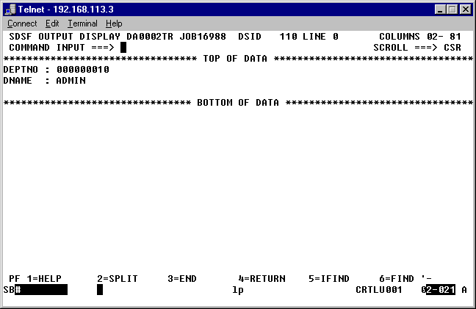

- Using and execution of embedded SQL (on IBM Mainframes)

Goals | - Application Development using COBOL-DB2
Time | 120 minutes

Write a COBOL programs:

- Display the details of the highest paid employee.

- Display the name and salary of the employee whose empno is passed on as a host variable. If the search returns a NULL value, a NULL INDICATOR should be used to indicate the appropriate error message.

- Refer to shared program ‘DB2PGM’ for fetching a single record from DB2 table for particular employee.

  - Do modify this given program to fetch corresponding records for all employees who belongs to Department 10.
  - Do refer to appropriate DB2 table and accordingly update the code.

- Write COBOL programs to fulfill the given requirements.

  - Increase the commission of employees, who have completed one year of service with following conditions (The % increase is w.r.t. the salary).
    - If salary > 10000 and salary <= 15000 grant him a commission of 20%
    - If salary > 15000 and salary <=20000 grant him a commission of 15%
    - If salary > 20000 grant him a commission of 10%
  - Compute and display the total salary of all the employees where the total salary is calculated as TSAL = SALARY + COMMISSION. An additional commission of 10% of salary is granted to those employees who work as salesmen in the firm. (Hint : Commission can be null)

  - Display the department name, location and the other employee details of all those employees who belong to department no. 10.

- Refer to shared data file named ‘PS.txt’ for the data.
Task list includes:
  - Transfer the above flat file to dataset.
  - Create a DB2 table using SPUFI
  - One application program to transfer data from PS to newly created DB2 table

File Description is given here for your reference.

FD PSFILE
LABEL RECORDS STANDARD
RECORDING MODE IS F
BLOCK CONTAINS 0 RECORDS
RECORD CONTAINS 99 CHARACTERS.
01 PS-REC.
05 PS-ID PIC 9(6).
05 PS-NAME.
10 C-FIRST-NAME PIC X(15).
10 C-LAST-NAME PIC X(15).
05 PS-DOB PIC X(10).
05 PS-HID PIC X(10).
05 PS-DEPT PIC X(1).
05 PS-GRADE PIC X(02).
05 PS-DESG PIC X(2).
05 PS-BASIC PIC 9(6).
05 PS-GENDER PIC X(1).
05 PS-MS PIC X(1).
05 PS-ADDRESS PIC X(20).
05 PS-PHN-NO PIC 9(10).

- Using and execution of embedded SQL (on IBM Mainframes)
Goals | - Application Development using COBOL-DB2- Case Studies
Time | 120 minutes

Problem Statement 1:

- Create the following table definitions and write programs to INSERT data into tables

  - Create TABLE CUST_MAST. (CUST_NO to be the PRIMARY KEY)
  - Create TABLE CUST_TRANS.
  - Create DCLGEN’s for both the tables created using the DB2I and option 2.

CUST_MAST
COLUMNS | SIZE | No of Decimal position | DATA TYPE
CUST_NO | 5 |  | INTEGER NOT NULL
CUST_NAME | 20 |  | VARCHAR NOT NULL
DT_OF_LAST_PURCHASE | 8 |  | DATE
AMOUNT_OWED | 9 | 2 | DECIMAL

CUST_TRANS
COLUMNS | SIZE | No of Decimal position | DATA TYPE
CUST_NO | 5 |  | INTEGER NOT NULL
DT_OF_PURCHASE | 8 |  | DATE NOT NULL
AMT_OF_PURCHASE | 7 | 2 | DECIMAL NOT NULL

- Write a program to then update the CUST_MAST table.

- If a transaction exists in CUST_TRANS table for which there is no corresponding row in CUS_MAST table, display it as an error
- For all transactions in CUST_TRANS table with corresponding row in the CUST_MAST table (these rows are to be updated), add the AMT_OF_PURCHASE from the CUST_TRANS to AMOUNT_OWED in the CUST_MAST table and UPDATE the column DT_OF_LAST_PURCHASE.

Problem Statement 2:

ABC Company’s monthly take-home salary is to be computed. The Company maintains the salary information of their employees in the EMPLOYEE table for computations.
Income Tax company has given the below data for computation of tax.

Create a new table TAX_DATA with the column names and also INSERT the data as mentioned in the table below:

TAXABLE_INCOME (INTEGER NOT NULL , Length 6) | FEDERAL_TAX_RATE (DECIMAL NOT NULL, Length V999) | STATE_TAX_RATE (DECIMAL NOT NULL, Length V999)
09800 | .040 | .010
12000 | .080 | .020
30000 | .150 | .040

Note: The State Tax is 1% and the federal tax 4% for taxable income less than or equal to 9800. The taxable income between 9801 and 12000 (inclusive), the state tax is 2% and federal tax is 8%. The taxable income between 12000 and 30000 (inclusive), the state tax is 4% and federal tax is 15%.

Calculate the Monthly statement based on the following conditions:

- Standard deduction = 10% of the first $10,000 of annual salary
- Social Security and Medicare Taxes
- Social Security Tax = 6.2% of the first $62,700 of annual salary
- Medicare Tax = 1.45% of each annual salary
- Taxable Income = Annual Salary – Standard Deduction – Dependent Deduction
- Use the Tax table and calculate the taxable income
- Annual Take-home pay = Annual salary – (state tax % * taxable income) – (Federal tax % * taxable income) - (Social Security Tax + Medicare Tax)
- Monthly take Home = Annual Take-home pay / 12

Write the Program to generate Flat file report for each employee monthly take home salary. For Taxable income write a subroutine to calculate the taxable income.

- Problem statements based on Analysis, Debugging and Enhancement tasks
Goals | - Application Development using COBOL-DB2- Case Studies
Time | 180 minutes

Problem Statement 1: Migration from FMS (file management system) to RDBMS (DB2)

Refer to ‘Bank Transaction Updation and Reporting’ Lab Exercise developed in COBOL training.
- Migrate the complete project from file system to RDBMS data base. Instead of using file system viz. Account Transaction file and the Account Master file, do use DB2 tables to maintain the data.

- Analyze the program, do the changes to Cobol code, remove the error and successfully execute the program.

- Document the error in the excel sheet along with steps taken to resolve the error.

Problem Statement 2: Migration from FMS (file management system) to RDBMS (DB2)

Refer to ‘Online Bus Booking’ Lab Exercise developed in COBOL training.
Online Bus Booking

You have a program to read Booking Trans file, Check the availability of the seat in the Bus Detail file, Generate Ticket no., PNR no., Update the Booking Master file, Update Bus Detail file, Print Tickets & Print canceled report in case of cancellation.

- Migrate the complete project from file system to RDBMS data base. Instead of using file system, do use DB2 tables to maintain the data.

- Analyze the program, do the changes to Cobol code, remove the error and successfully execute the program.

- Document the error in the excel sheet along with steps taken to resolve the error.

Problem Statement 3: Analyzing the given code and do enhancement.

Refer to shared ‘Login Program’ and ‘Login Map’ for both COBOL-CICS and BMS coding.
- Analyze the program
- Do create required tables along with data in database.
- Make the required changes to code and successfully execute the programs.
- Display the appropriate messages on the map based on successful login as well for failed to login due incorrect login credentials.
- Document the error in the excel sheet along with steps taken to resolve the error.

Appendices

Appendix A: JCL’s

//DA0001TC JOB (LA2719),'FACULTY',CLASS=A,
// MSGCLASS=X,
// NOTIFY=DA0001T,
// TIME=(,01),
// REGION=4096K
//*ROUTE PRINT RMT196
//**************************************************************
//* THIS JCL PRECOMPLILES THE APPLICATION PGM
//* GENERATES PURE COBOL CODE AND A DBRM.
//**************************************************************
//PRECOMP EXEC PGM=DSNHPC,
// PARM='HOST(COBOL),APOST',REGION=4096K
//*
//* IN SYSIN GIVEN BELOW SPECIFY PGM NAME TO BE PRECOMPILED
//* B
//SYSIN DD DSN=DA0001T.FACULTY.DB2SORCE(ASS1),DISP=SHR
//*
//SYSLIB DD DSN=DA0001T.FACULTY.DB2SORCE,DISP=SHR
//*
//SYSUT1 DD UNIT=SYSDA,SPACE=(CYL,(5,5))
//SYSUT2 DD UNIT=SYSDA,SPACE=(CYL,(5,5))
//SYSUT3 DD UNIT=SYSDA,SPACE=(CYL,(5,5))
//STEPLIB DD DSN=SYS0.DB2.TEST.DSNLOAD,DISP=SHR
//*
//* HERE YOU SPECIFY O/P MEMBER OF PRECOMPILATION
//*
//SYSCIN DD DSN=DA0001T.FACULTY.DB2SORCE(MASS1),
// DISP=(SHR),UNIT=SYSDA,
// SPACE=(CYL,(5,5,4))
//* HERE YOU SPECIFY MEMBER FOR DBRM
//DBRMLIB DD DSN=DA0001T.FACULTY.DBRMLIB(DASS1),DISP=SHR
//* DISP=(NEW,KEEP),UNIT=SYSDA,
//* SPACE=(CYL,(5,5))
//*
//SYSPRINT DD SYSOUT=*
//SYSTERM DD SYSOUT=*
//SYSUDUMP DD SYSOUT=*
//

//DA0001TA JOB (LA2719),'FACULTY',CLASS=A,
// MSGCLASS=X,
// NOTIFY=DA0001T,
// TIME=(,01),
// REGION=4096K
//*ROUTE PRINT RMT196
//**************************************************************
//* THIS JCL BIND THE DBRM & GENERATES APPLICATION PLAN
//*
//**************************************************************
//BIND EXEC PGM=IKJEFT01,DYNAMNBR=20,REGION=512K
//STEPLIB DD DSN=SYS0.DB2.TEST.DSNLOAD,DISP=SHR
//*TEPLIB DD DSN=SYS1.DB2.SDSNLOAD,DISP=SHR
//*YSPROC DD DSN=SYS1.DB2.SDSNCLST,DISP=SHR
//*
//* HERE YOU SPECIFY DBRM LIBRARY
//*
//DBRMLIB DD DSN=DA0001T.FACULTY.DBRMLIB,DISP=SHR
//*
//DB2ERROR DD SYSOUT=*
//CSABEND DD SYSOUT=*
//SYSABOUT DD SYSOUT=*
//SYSDBOUT DD SYSOUT=*
//SYSUDUMP DD SYSOUT=*
//SYSPRINT DD SYSOUT=*
//SYSTSPRT DD SYSOUT=*
//SYSOUT DD SYSOUT=*
//SYSTSIN DD *
DSN SYSTEM(DST2) RETRY(5) TEST(0)
BIND PLAN(DAPLAN1) -
MEMBER(DASS1) -
ACTION(REPLACE) RETAIN -
ISOLATION(CS) -
VALIDATE(RUN) -
ACQUIRE(USE) -
RELEASE(COMMIT)
END
/*

//DA0001TC JOB (LA2719),'FACULTY',CLASS=A,
// MSGCLASS=X,
// NOTIFY=DA0001T,
// TIME=(,01),
// REGION=4096K
//***********************************************************
//* THIS JCL COMPILES AND LINK THE PRECOMPIED PGM
//*
//***********************************************************
//* THIS STEP COMPILES THE PRECOMPILED PGM
//***********************************************************
//COB EXEC PGM=IKFCBL00,REGION=1024K,
// PARM='NOTRUNC,NODYNAM,LIB,SIZE=4096K,BUF=116K,APOST,NORES'
//* PARM='LOAD,SUPMAP,APOST'
//SYSLIB DD DSN=SYS1.COBCOMP,DISP=SHR
//SYSPRINT DD SYSOUT=*
//* HERE TEMP DATASET TO RECEIVE O/P OF COMPILATION
//*
//SYSLIN DD DSN=&&TEMP,DISP=(NEW,PASS),
// UNIT=SYSALLDA,SPACE=(TRK,(40,40))
//*****************************************************
//SYSUT1 DD UNIT=SYSALLDA,SPACE=(TRK,(6,1))
//SYSUT2 DD UNIT=SYSALLDA,SPACE=(CYL,(6,1))
//SYSUT3 DD UNIT=SYSALLDA,SPACE=(CYL,(6,1))
//SYSUT4 DD UNIT=SYSALLDA,SPACE=(CYL,(6,1))
//* **************************************************
//* HERE YOU SPECIFY PRECOMPILED PGM MEMBER
//*
//SYSIN DD DSN=DA0001T.FACULTY.DB2SORCE(MASS1),DISP=SHR
//****B***********************************************
//* STEP TO LINK THE COBOL PROGRAM
//****************************************************
//LKED EXEC PGM=IEWL,PARM='LIST,XREF,LET,MAP',
// REGION=4096K,COND=(5,LT,COB)
//SYSLIN DD DSN=&&TEMP,DISP=(OLD,DELETE)
//SYSLIB DD DSN=SYS1.COBLIB,DISP=SHR
// DD DSN=SYS0.DB2.TEST.DSNLOAD,DISP=SHR
//SYSLMOD DD DSN=DA0001T.FACULTY.LOADLIB(ASS1),DISP=SHR
//* UNIT=SYSALLDA
//SYSUT1 DD UNIT=SYSALLDA,SPACE=(CYL,(6,1))
//SYSPRINT DD SYSOUT=*

//DA0001TA JOB (LA2719),'FACULTY',CLASS=A,
// MSGCLASS=X,
// NOTIFY=DA0001T,
// TIME=(0,1),
// REGION=4096K
//*ROUTE PRINT RMT196
//**************************************************************
//* THIS JCL EXECUTES THE BATCH DB2 APPLICATION
//*
//**************************************************************
//RUNPGM EXEC PGM=IKJEFT01,DYNAMNBR=20,REGION=512K
//STEPLIB DD DSN=SYS0.DB2.TEST.DSNLOAD,DISP=SHR
//*TEPLIB DD DSN=SYS1.DB2.SDSNLOAD,DISP=SHR
//*YSPROC DD DSN=SYS1.DB2.SDSNCLST,DISP=SHR
//*BRMLIB DD DSN=DA0001T.SOURCE.DBRM,DISP=SHR
//*
//* HERE YOU SPECIFY DBRM LIBRARY
//*
//DBRMLIB DD DSN=DA0001T.FACULTY.DBRMLIB,DISP=SHR
//*
//DB2ERROR DD SYSOUT=*
//CSABEND DD SYSOUT=*
//SYSABOUT DD SYSOUT=*
//SYSDBOUT DD SYSOUT=*
//SYSUDUMP DD SYSOUT=*
//SYSPRINT DD SYSOUT=*
//SYSTSPRT DD SYSOUT=*
//SYSOUT DD SYSOUT=*
//SYSIN DD *
//*1
//*
//SYSTSIN DD *
DSN SYSTEM(DST2) RETRY(5) TEST(0)
RUN PROGRAM(ASS1) -
PLAN(DAPLAN1) -
LIB('DA0001T.FACULTY.LOADLIB')
END
/*

Appendix B: DB2 datatypes and the COBOL equivalent Picture

clauses

DB2 datatype | COBOL picture clause
SMALLINT | PIC S9(4) COMP.
INTEGER | PIC S9(9) COMP.
DECIMAL (3,2)  DECIMAL (15,2)  DECIMAL (9,4) | PIC S9V99 COMP-3.  PIC S9(13)V99 COMP-3.  PIC S9(5)V9(4) COMP-3.
CHAR (10) | PIC X(10).
VARCHAR(20)  E.G. JOB VARCHAR(20) | 01 JOB.  49 JOB-LEN PIC S9(4) COMP.  49 JOB-TEXT PIC X(20).
DATE | PIC X(10)
INDICATOR VARIABLES | PIC S9(4) COMP.

DB2 Data Type | Cobol | Maximum Value/Format
smallint | PIC S9(4) COMP | range of values -32,768 to +32,767
integer | PIC S9(9) COMP | range of values -2,147,483,648 to +2,147,483,647
decimal(p,s) | PIC S9(p)V9(s) COMP-3 | p is the total number of digits, s is the number of digits to the right of the decimal
char(n) | PIC X(n) | n cannot exceed 254
varchar(n) | 01 IDENTIFIER  49 IDENTIFIER-LEN PIC S9(4)  49 IDENTIFIER-TEXT PIC X(n) | n is maximum length and cannot exceed 254
date | PIC X(10) | format: yyyy-mm-dd
time | PIC X(6) OR PIC X(8) | format: hh.mm.ss
timestamp | PIC X(26) | format: yyyy-mm-dd-hh.mm.ss.nnnnnn
Graphic | PIC G(n) | n must be between 1 and 127 and refers to the number of double-byte characters, not the number of bytes

Appendix C: SQLCA

Fields of SQL Communication Area

01 SQLCA.
05 SQLCAID PIC X(8).
05 SQLCABC PIC S9(9) COMP-4.
05 SQLCODE PIC S9(9) COMP-4.
05 SQLERRM.
49 SQLERRML PIC S9(4) COMP-4.
49 SQLERRMC PIC X(70).
05 SQLERRP PIC X(8).
05 SQLERRP OCCURS 6 TIMES PIC S9(9) COMP-4.
05 SQLWARN.
10 SQLWARN0 PIC X.
10 SQLWARN1 PIC X.
10 SQLWARN2 PIC X.
10 SQLWARN3 PIC X.
10 SQLWARN4 PIC X.
10 SQLWARN5 PIC X.
10 SQLWARN6 PIC X.
10 SQLWARN7 PIC X.
05 SQLEXT PIC X(8).

Appendix D :List of SQL codes

SQLCODE | Keyword | Meaning
+100 | SELECT | Row not found during FETCH, SELECT, UPDATE or DELETE
+304 | Program | Value and host variables are incompatible
-305 | Variables | Null values occurred, and no indicator variable was defined
-501 | Cursor | Cursor named in FETCH or CLOSE is not open
-551 | Authority | You lack the authority to access the named object, possibly because the name is not spelled correctly
-803 | Updating | Duplicate keys not allowed
-805 | Plan | DBRM not bound into this plan
-811 | SELECT | Embedded SELECT or sub select returned more than one row
-818 | Plan | Timestamps in load module and plan do not agree; program was probably re-precompiled without being re-bound
-901 | System | Mysterious system error, permits running more SQL statements
-904 | System | Unavailable resource; if resource name is a table view, et. This was probably caused by contention and re-trying the operation may work; if resource name is a 44 character VSAM file name, the file has probably been archived or deleted
-911 | System | Deadlock or timeout, updates rolled back
-913 | System | Deadlock or timeout, updates not rolled back
- Using and execution of embedded SQL (CA-Realia Workbench )

Goals | - Understand how to execute embedded SQL on CA-Realia Workbench.
Time | 60 minutes

Steps

- Create a user-defined DSN
- Setup CA-Realia Workbench
- Create table definitions
- Key in the program
- Compile the program
- Link the program
- Debug

1. Create a user-defined DSN

Note : We will be creating a DSN to connect to a SQL Server database on the SPZ_EJB_SRV server.

From the Windows Start Menu select Settings-> Control Panel -> Data Sources (ODBC). The following window is displayed. Click on the Add button.

In the Create New Data Source window select SQL Server and click on the Finish button.

On this screen you will have to provide a name for this data source. We will have to specify this name in CA-Realia Workbench. Select the server on which the SQL Server database resides. Click on the Next> button.
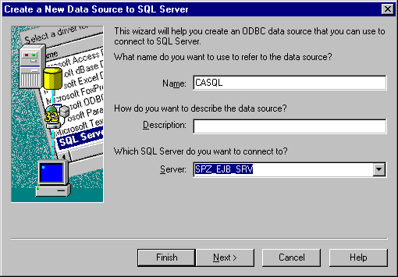

Select the type of authentication. Here we will select With SQL Server authentication using a login id and password entered by the user. Select Connect to SQL Server to obtain default settings for the additional configuration options. Specify your login id and password for the SQL Server database. Click on the Client Configuration button.
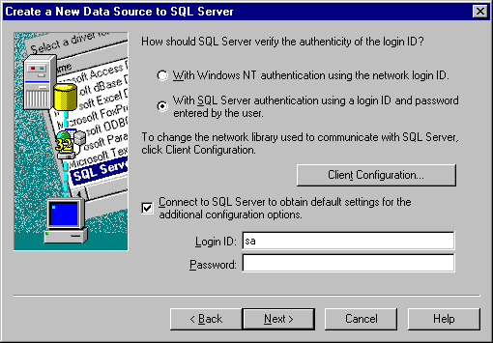
Figure 49

Check the Network Library Configuration settings. Click on the OK button. Click on the Next> button on the Create a New Data Source to SQL Server dialog window.

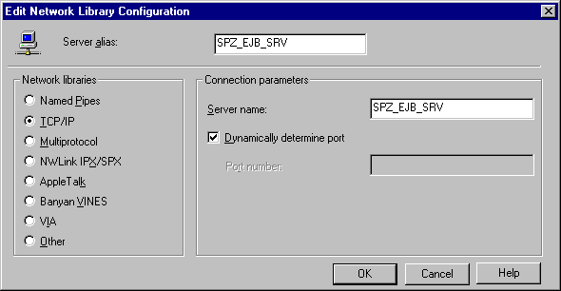

Select the Change the default database to checkbox. We have our sample tables created on the tempdb database, hence we have selected tempdb from the dropdown list. Click on the Next> button.
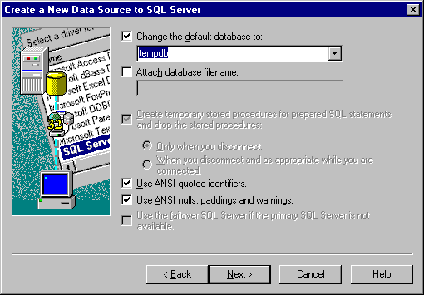
Figure 51

Select Perform translation for character data and click on the Finish button.
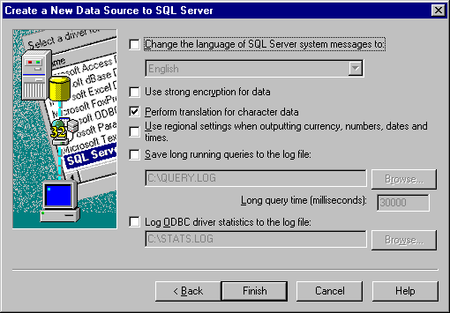
Figure 52
Select the Test Data Source button. Click on the OK after the Testing is successful.
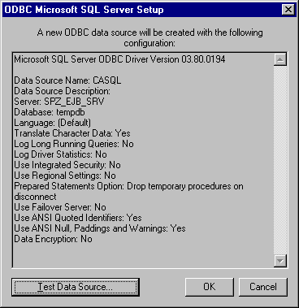
Figure 53

2. Setup CA-Realia Workbench

Start CA-Realia Workbench
Select Build -> Options -> System DEFAULT

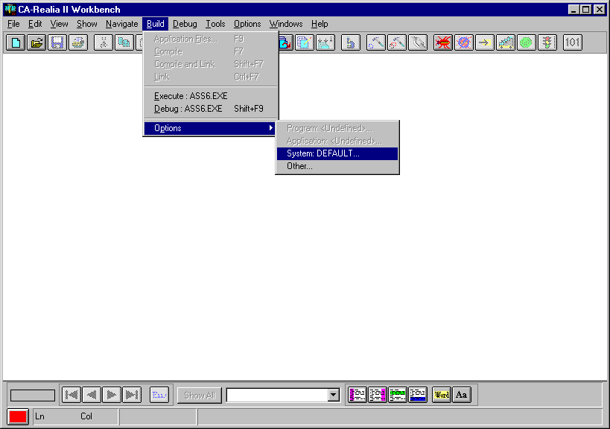
Figure 54

We will have to add a reference to the DB2COPY folder in the Workbench folder, as this directory contains the copy books e.g. SQLCA. We will also give a reference to our directory where we store our copy books (for table definitions).

Add C:\CAWB31\DB2COPY;H:\ANNETTE\CA in the Copy Book Path.
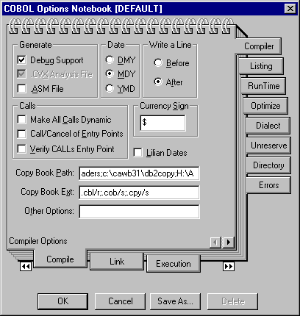
Figure 55

In the Link tab in COBOL Options Notebook mention the following library files :
Carcodbc.lib
Carclw60.lib

Specify the Library File Path as C:\CAWB31\LIB.
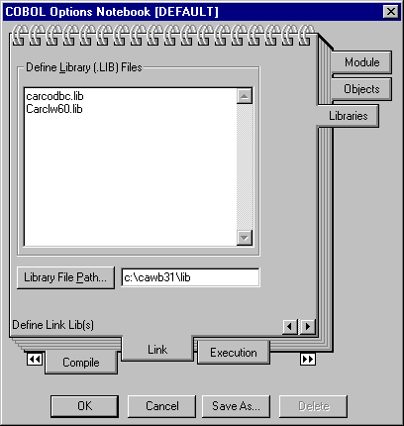
Figure 56

In the Preprocessor tab, select the Preprocessor Group as ODBC. ODBC appears in the list of Associated steps. Click on the ODBC step in the associated steps group. The Options and View Step… button will be enabled. Click on the Options button.

Figure 57

In the Connect group select the connection type as Type 2, Implicit Connect, against Database enter the name of the user-defined DSN which we created earlier.
In the SQL group select DB2.
Click on the OK button.

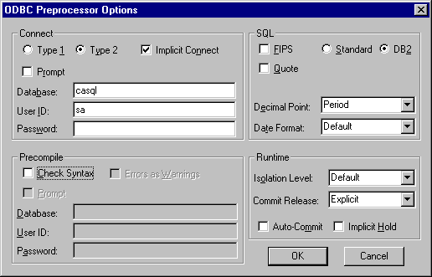
Figure 58

3. Create table definitions

For the following table definition :

( DEPTNO INTEGER NOT NULL,
DNAME CHAR(10),
LOCATION VARCHAR(10)
)

The COBOL definition would be as follows :
01 DCLDEPT.
10 DEPTNO PIC S9(9) USAGE COMP.
10 DNAME PIC X(10).
10 LOCATION.
49 LOCATION-LEN PIC S9(4) USAGE COMP.
49 LOCATION-TEXT PIC X(10).

Save the COBOL definition as DCLDEPT.cpy in the folder H:\ANNETTE\CA (The path for the copy books).

4. Key in the program

Key in the following program and save it as Prg1.cbl in the H:\Annette\CA folder.

IDENTIFICATION DIVISION.
PROGRAM-ID. PRG1.
AUTHOR. ANNETTE.
***************************************************************
* Display the name of the department, given the department no.*
***************************************************************
ENVIRONMENT DIVISION.
DATA DIVISION.
WORKING-STORAGE SECTION.
EXEC SQL
INCLUDE DEPTDCL
END-EXEC.
*
EXEC SQL
INCLUDE SQLCA
END-EXEC.
PROCEDURE DIVISION.
0000-MAIN-PARA.
* Checking a row with salary as null.
MOVE 10 TO DEPTNO.
EXEC SQL
SELECT DNAME
INTO :DNAME
FROM DBO.DEPARTMENT
WHERE DEPTNO = :DEPTNO
END-EXEC.
DISPLAY 'DEPTNO : ' DEPTNO.
DISPLAY 'DNAME: ' DNAME.

STOP RUN.

5. Compile the program

To compile the program, select Build -> Compile.

6. Link the program

After successful compilation, select Build -> Link .

Create a new profile for executing the program. Select Build -> Options -> System: DEFAULT …
In the Execution tab,
In the Execution tab of the COBOL Options Notebook, create a new Execution Profile by clicking on the New button.

Enter the profile name. In the Execution group, click on the EXE File Name button and select the name of the executable file. This file name to the appropriate executable file to be run. Select the working directory, the directory which contains the executable files.

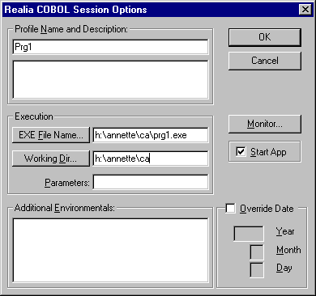
7. Debug the program

To check the output of the program, click on the Debug icon. Step through the program, the output of the program is displayed.

